Add the Zoom Integration to Brightspace

- Open your Brightspace course and click Content from the course navigation bar.

- Open an existing module where the Zoom link should reside, or create a new module using the Add a module text box.

- Click Existing Activities and select External Learning Tools from the drop-down.

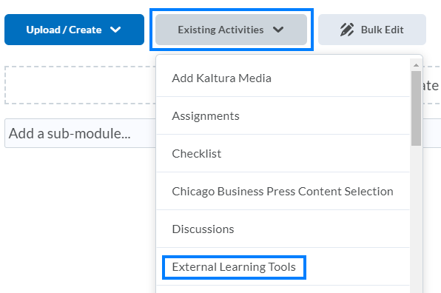

- Select Zoom from the list of available tools.

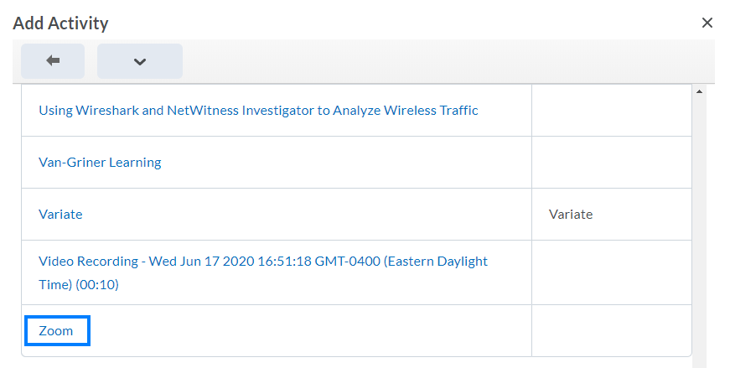
- Click the Zoom link that has been added to the course module.

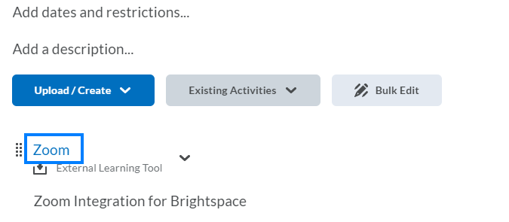

- Click Schedule a New Meeting and proceed with scheduling your class meeting.

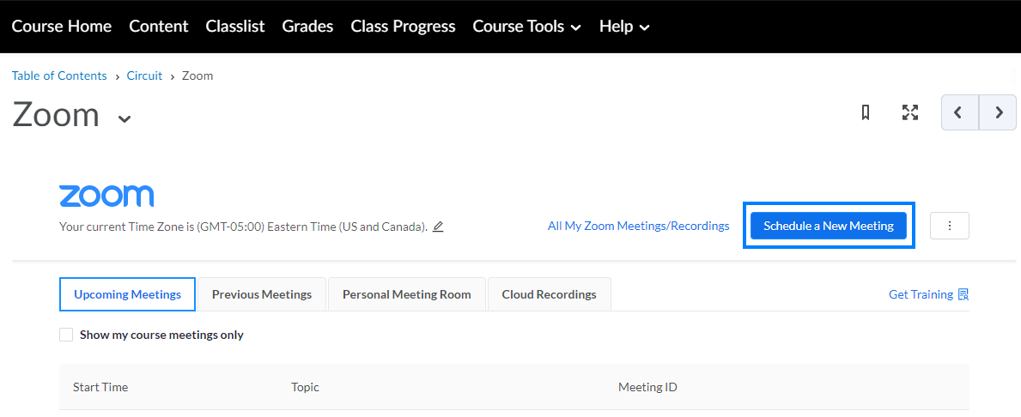

- When students login, the Zoom link in the module will take them to a page listing the upcoming Zoom meetings with a button to join.

