Transfer Zoom Recordings from the Cloud to Brightspace

In Zoom
- Navigate to https://purdue-edu.zoom.us/.

- Click Recordings from the menu on the left.

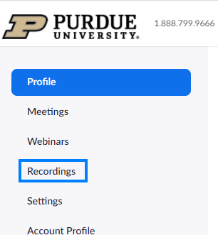

- Locate the recording you would like to add to Brightspace, click More, and select Download (2 files) from the drop-down.

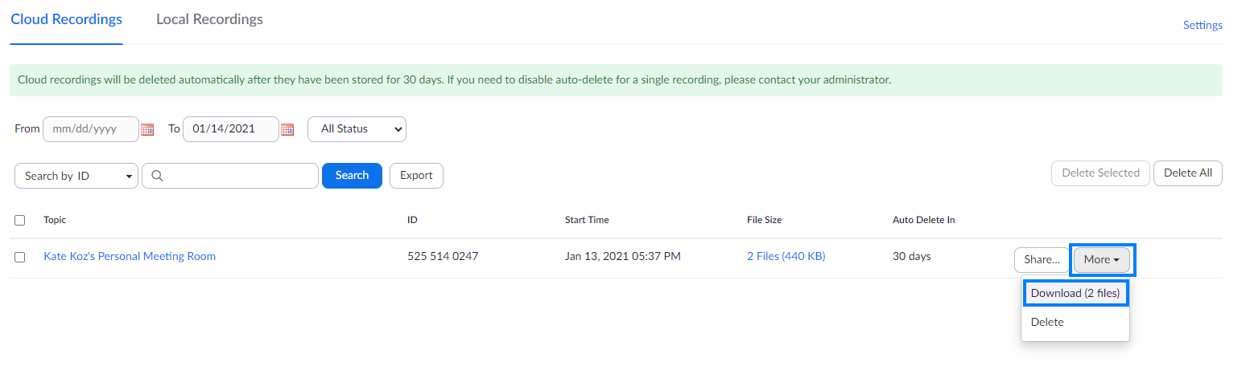

In Brightspace
- Open your Brightspace course and click Content from the course navigation bar.

- Open an existing module where the Zoom recording should reside, or create a new module.

- Within the module, click Existing Activities and select Add Kaltura Media from the drop-down.

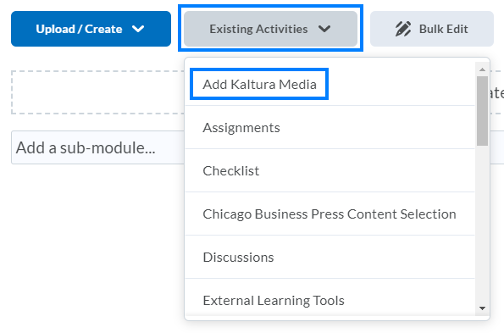

- Click the + icon near the top-right and select Media Upload from the drop-down.

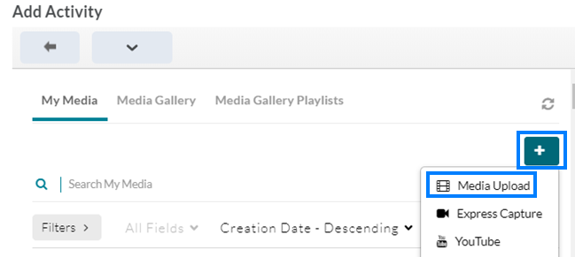

- Click Choose a file to upload and locate the Zoom recording you would like to upload.

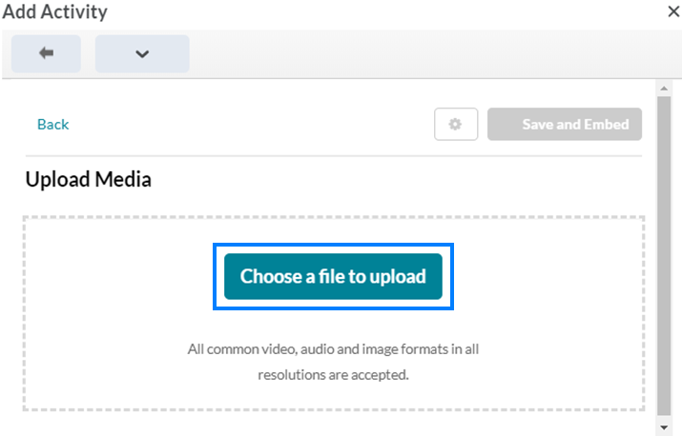
- After the upload finishes, click Save and Embed near the top-right.

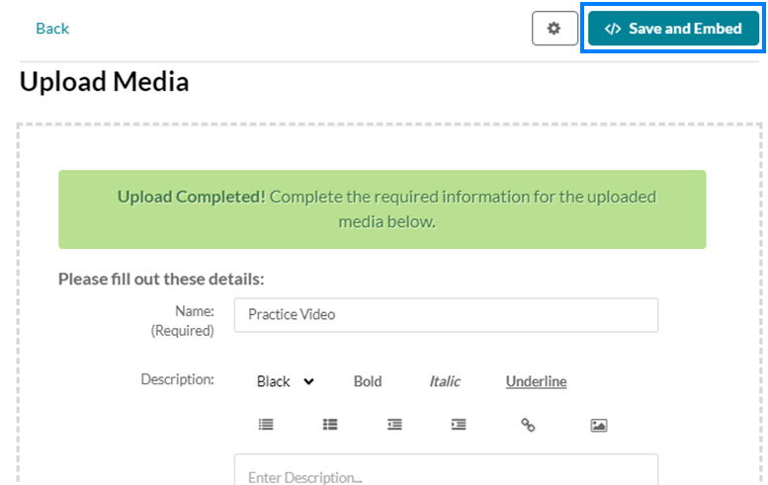

- This will add the video to the bottom of the content within the module you have selected. You can reposition this wherever you might like by clicking the 8 dots to the left of the video link and dragging to the desired location. The video may not be visible right away due to processing/rendering times.

